

Report generation

Java



computer technology

Amrutvahini Polytechnic, Sangamner

**Micro-Project Report**

**Report Generation**

**1.0 Rationale**

Report generation is integral part of an educational universties also industries. We are creating report generation using java to handle all the reports generation requirements of user.

1. **Aims/Benefits of the Micro-Project.**

To Design a java program report generation and control it using various java components.

**3.0 Course Outcomes Addressed**

1. Develop programs using object oriented methodology in java.

c. Develop programs using multithreading.

1. Apply concept of inheritance for code reusability.
2. **Literature Review**

We will developed the report generator to keep the track of student marks or our data in simplified GUI. The project consists of several classes working together - most of them are provided for us. Most of required classes are already defined in java. We have created project using regular classes and we just have to import them. Following are the packages imported:

* import java.util.*;

1. **Actual Methodology Followed:**

We have used util package to perform operations. We have used scanner class to get input from user also used switch case to perform operation according to admin choice. We also provide the admin login to keep the applicatiion security.

**Algorithm**

**Step**

1. Start
2. Ask admin for username and password
3. Main Menu should be displayed after admin login.
4. If admin selects to add student details. Then it asks for several information of student to admin:
5. Student ID
6. Student Name
7. FY Percentage
8. SY percentage
9. TY percentage
10. If admin selects to show student report details then admin can see the student report of student.
11. If admin can selects logout option the logout successfully message displayed and program will be terminated.
12. **Actual Resources Used**

|  |  |  |  |  |
| --- | --- | --- | --- | --- |
| S.  No. | Name of Resource/Material | Specification | Qty. | Remarks |
| 1) | Laptop | Intel (R) Core i3- 4GB RAM | 1 | - |
| 2) | Eclipse | Oxygen-64bit | 1 | - |
| 3) | Reference Website | www.javapoint.com | - | - |

1. **Outputs of the Micro-Projects**

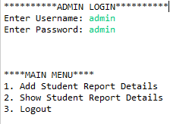

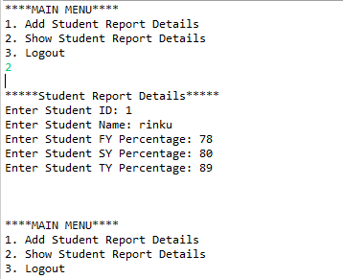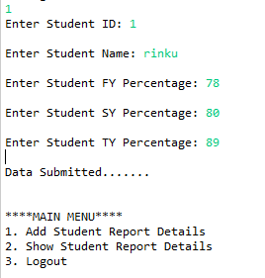 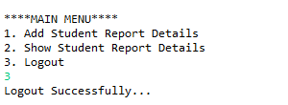

**8.0 Skill Developed / Learning outcomes of this Micro-Project**

1. Create class and objects for this project.
2. Apply identify type of initialize for the given program.
3. Use of scanner class.
4. Use of switch case.
5. **Application of this Micro-Project**
6. The use of report generation in education and other professional fields.
7. Java can be used to create complete applications that may run on a single computer or be distributed among server and client in network.
8. Java is used for web applications like a google documents.